**School of Information Sciences**

Term Seminar

**Network I/O Virtualization For Cloud Computing**

|  |  |  |  |
| --- | --- | --- | --- |
| **Registration Number** | **Name** | **Branch** | **E-mail** |
| **161041004** | **Daneshwari Kadlimatti** | **Computing Technologies and Virtualization** | **daneshwari.k6@gmail.com** |

**Guide/Panel Team**

|  |
| --- |
| Name |
| **DEEPAK RAO** |
| **SHREEPATHY HV** |

**Table of Contents**

Abstract……………………………………………………………..3

Chapter1……………………………………………………...…......4

Introduction……………………………………………...……4

Chapter-2……………………………………………………………6

Distributed mobility managements…………………………...6

Chapter-3……………………………………………….…………...7

Description of the three DMM solutions………….…………..7

Chapter-4……………………………………………...……………13

Features of the three DMM solutions…………...……………13

Chapter-5…………………………………………………………...14

Experimental results………………………………………….14

Chapter-6…………………………………………………………...17

Conclusion……………………………………….…………...17

Chapter-7……………………………………………….…………..18

References……………………………………………………18

**Abstract**

The most trending area of research in these days is cloud computing, which goes in parallel with one or more important concept in the development of hardware and software which is virtualization technology.

Network I/O virtualization is essential in data-center hosts to provide network connectivity to virtual machines.

As network I/O virtualization evolves, several proposals have emerged to address the complexity and performance issues through synergistic software and hardware solutions.

The network I/O virtualization technologies let multiple VMs share common network links and bandwidth. This sharing greatly reduces the cost of network devices and the port density requirements on switches.

# Chapter – 1

## Introduction

Cloud computing now a days is one of the most trending technology, as it is difficult to store huge data in a specified storage area the cloud concept is evolved. So cloud computing can be said as a technology that allows users to access large amount of data, information and various other computing resources in a manner in which the customer uses the resources and pays for it accordingly.

Virtualization is the act of creating something

What is virtualization?

It is the technique that helps to improve the efficiency of cloud computing. With the help of virtualization, it is possible to work on multiple operating systems and applications simultaneously over the same server, hence virtualization increases the utility and flexibility of hardware.

# Chapter-2

**Network I/O Virtualization**

**(I/O) virtualization** is a methodology to simplify management, lower costs and improve performance of servers in enterprise environments. I/O virtualization environments are created by abstracting the upper layer protocol from the physical connections

Network I/O virtualization is the technology enables one physical adapter card to appear as multiple virtual network interface cards (vNICs) and virtual host bus adapters

**Chapter-3**

**NIC Bridging**

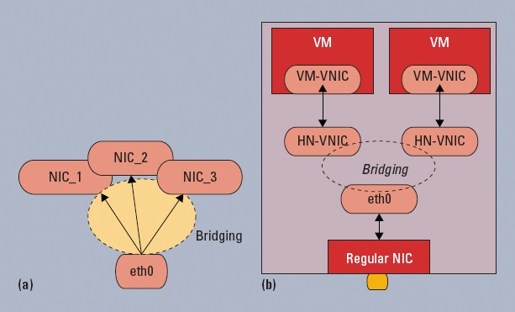

**Figure 1: Network bridging: (a) regular network interface card (NIC)bridging and (b) virtual NICs bridging for virtual machines (VMs).**

**Chapter-4**

**Link Aggregation**

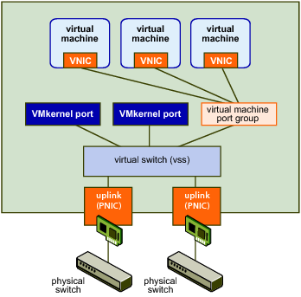

**Chapter-5**

**Advanced I/O Virtualization**

As network I/O virtualization evolves, several proposals have emerged to address the complexity and performance issues through synergistic software and hardware solutions.

Here, a software-oriented approach and two hardware-oriented approaches are briefly introduced.

**NIC Bonding:**

Also known as link aggregation,NIC bonding groups multiple physical network links and provides the network bandwidth as an aggregate logic to the VMs (see Figure 2). NIC bonding can break link bandwidth ceilings with little cost and improve the network connection’s reliability. It eases the virtual link management for VMs as well.

**VMDq.** Intel has proposed using Virtual MachineDevice Queues (VMDq) to offload the host CPU from sorting and multiplexing the packets to and from VMs.1 At the chipset level (Intel 82598, for example), VMDq handles parallel queues of packets, routing them to the appropriate VMsand offloading the VMM. Experimental data shows that with VMDq, the network throughput can reach up to 9.5 gigabits per second, compared to 4 Gbps for a design without VMDq.1

* **SR-IOV.** Single Root I/O Virtualization is a newly proposed Peripheral Component Interconnect (PCI) feature, which creates virtual functions that share a physical function’s resources.2 So, multiple VMs running in a single computer can share natively a single PCI device. New NICs usually support the SR-IOV feature, which significantly reduces the overhead of resource sharing and of control for network I/O virtualization.

**The Challenges**

* **The management complexity.**
* **The complexity of packet multiplexing.**
* **The ever increasing line rate.**
  + **To address these challenges, new technologies have emerged for new virtualization layers and host/NIC architectures**

Chapter-6

Technologies of Virtualization

* **Virtual Switching in Data Centers**
* **In-Host Virtual Switch**

**Chapter-7**

**Cloud Computing**

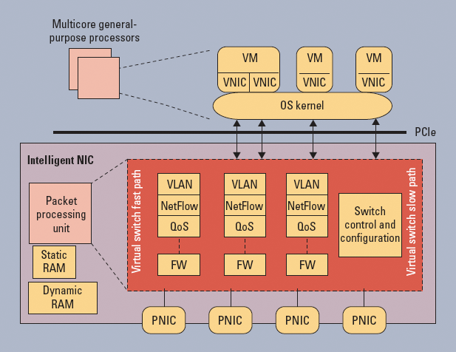

**Chapter-7**

**Advantages of intelligence NIC over cloud computing**

* Leading to better packet-switching performance than the host CPUs.
* It leads to better resource utilization at the hosts.
* The isolation of computing and packet switching.
* The separate domain (NIC) for packet switching also improves the data center networks’ security and reliability.

Chapter-7

Conclusion

The Packet switching is faster as compared to host network. Resource utilization is done efficiently. Through network I/O virtualization security and reliability is achieved efficiently, improves the efficiency of cloud computing.

Chapter-7

References

[1] S. Chinni and R. Hiremane, “Virtual Machine Device Queues: An Integral Part of Intel Virtualization Technology for Connectivity that Delivers Enhanced Network Performance,” white paper, Intel, 2007.

[2] *Single Root I/O Virtualization and Sharing Specification*, revision 1.0, specification by Peripheral Component Interconnect Special Interest Group, Sept. 2007.

[3] B. Pfaff et al., “Extending Networking into the Virtualization Layer,” *Proc. Eighth ACM SIGCOMM HotNets Workshop*

[4] N. Mckeown et al., “OpenFlow: Enabling Innovation in Campus Networks,” white paper, The OpenFlow Switch Consortium, Mar 2008; [www.openflowswitch](http://www.openflowswitch/). org//documents/openflow-wp-latest.pdf.